Suggested Age Range: 8 - 9 years; 9 - 10 years; Adult
UK Curriculum: Key Stage Two (Upper)
Suggested UK Year Group: Year Four; Year Five
UK Primary Curriculum Link: States of Matter; Earth and Space
Science Subject: Stars
Science Questions: What are Stars? What are Constellations?
Suggested Science Activity: Star Crowns; Constellations, Star Maps
Children with SEND: Use to boost speech and language development
EAL children: Intermediate Level
Country of Origin: First Nations of America
Sources: “The Star Husband” CD by Lynn Moroney; Star-lore by F. Harrison-Hall

There was once a young girl who dreamed …
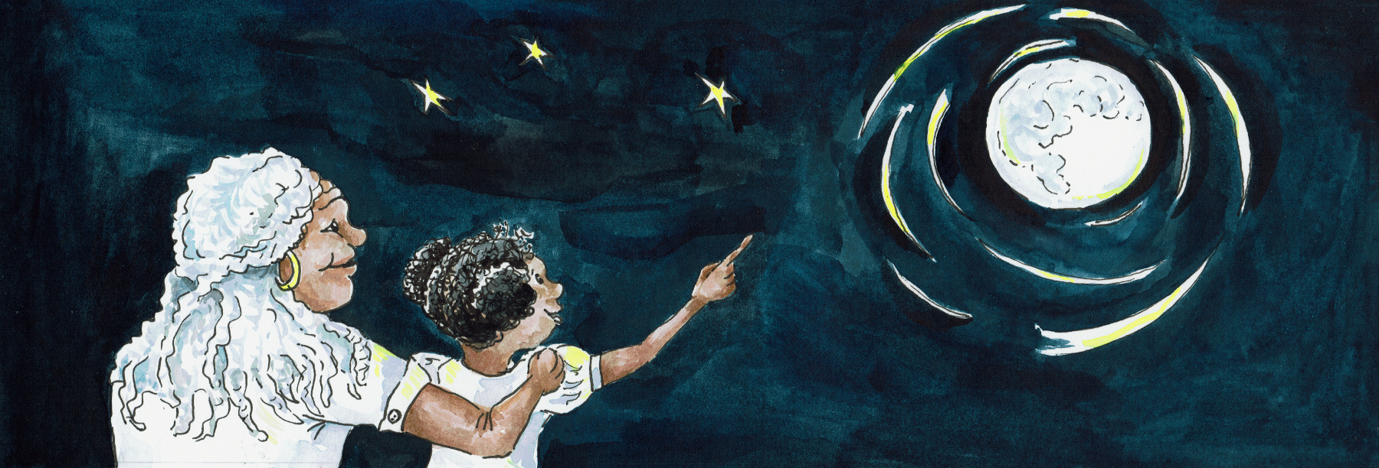
During the daytime - she spent her time stitching, learning to make the beautiful beaded necklaces, vests and shoes, that her people made and traded across the land.
And then at night, she was so tired that she fell into a deep and dreamless sleep.
As she grew up, her skill for beading became admired by all

And then, one night she dreamed.
And in her dream, she saw a star-lit path leading away from her people.

The stars showed her a path - across the prairie and into a forest. At the edge of the forest, she saw a tent all alone. And in that tent lived seven brothers, who lived on their own, without a family to take care of them.

The next day, she got up, and without speaking to anyone, she began to cut and to stitch. She stitched seven jackets, each one a little larger than the one before.
She decorated the arms and waist of each jacket with a shimmer of beads.
And when they were finished, she wrapped them in a piece of leather, gathered up her belonging and she left her home.

She followed the stars that she had seen in her dream, through the prairie and into the forest. At the edge of the forest, there was the tent, bedraggled and forlorn.
Kneeling on the ground in front of the tent, was the youngest brother. He was adding sticks to the fire. The boy heard a twig snap and he looked up.

He saw a stranger, a girl, coming towards him, out of the forest where a stranger had never come before. He was scared, so she stopped a little way from him, and placed the parcel she was holding on the ground between them. She opened it carefully and took out - the most beautiful thing the boy had ever seen!

A jacket but such a jacket!

Made of leather, smooth and oiled, and with a fringe on both the arms and around waist. And the fringe was made of beads that glistened in the sun!

Oh he longed to touch it, to wear it! She offered it to him and he put it on.
It fitted, perfectly, just as in her dream. And the boy turned slowly, holding up one arm and then another and the beads shivered a little as he moved.
And he smiled at her, his first smile, in such a long time.

And that night, as the stars appeared in the sky, the other brothers came back and saw the two of them together. And then they saw what their baby brother was wearing!

Oh, how they wished for something as beautiful as that!

And then the young girl handed each brother the jacket she had made for them.
And each of the jackets fitted perfectly.

As the seven brothers held up their arms to see the beads shimmer in the starlight, they began slowly to dance their joy, the first time they had danced in such a long, long time.

And so the girl stayed with them and became a big sister to them all.

She taught them all the skills, that her elders had taught to her. How to hunt and catch deer. How to prepare and preserve the meat with herbs so that not a single scrap of food was wasted. How to use the animals skin, to dry it into leather and to cut and shape and stitch the leather into clothes. How to make a new covering for their tipi, their home.

And together, they lived in their new home.

People began to travel past their tipi. And they would trade, woven blankets in return for the beaded clothes. Word spread of this young woman and the gift of her needle.

And word spread until it reached the King of the Bison, the Buffalo, who ruled the Prairie, so long ago. And the King of the Buffalo wanted her for himself, to be his wife.
And what he wanted, he took, for he was the King.
One day the King’s messenger, a young Bison came to the door of the tent:
“The King of the Buffalo wants you for his wife.”

“No!” she said. “ I will not go!” “I dreamed of my brothers and I came to live with them. They needed me and need me still. Here I stay. You may tell your King - NO!”

“You will tell have to tell him that yourself” said the young Bison..”You will not be able to say “No” to him, when he comes.”

One night, the family was woken by the sound and the feel of the ground trembling beneath them. They woke and went outside to see a wave of brown, thousands of Bison, thundering across the ground towards them.

“Quick!” said the eldest brother. “We must run!”

He grabbed his sister and ran, and his brothers followed him.
They ran, out of the tent and into the forest, into the safety of the trees.
But the Bison came after, closer and closer until they reached the furthest edge of the forest, and there was no-where left to run.

“Quick” cried the second brother “We must climb!”

And they climbed up and up a tree to the very top - where they were safe.
Or should have been.
But - the Bison surrounded the tree and began to stamp upon the ground.
And as they stamped, the tree began to sway, the roots began to creak and the tree began to break.The family clung on, but they knew their end was coming.

“You must go!” the brothers cried.

“No! said their sister. “Not ever. My place is with you. Here I dreamed and here I stay!
But if we cannot live on Earth any longer - shall we make a new home in the Sky?”

“Yes!” said her brothers replied.

And so she jumped into the Sky, and behind her, jumped her brothers, one by one.
And as they jumped they rose. And as they rose, they became brighter and brighter and lighter and lighter until they were changed into stars

The sister became the Home Star, for she, was the one who made their lonely tipi into a home. And the seven brothers swirl around her to make the shape of what in UK, we the Plough and what is called in America, the Big Dipper or the Drinking Gourd.
And it is those same stars, that the slaves in the Southern states of America, followed to find their own way to freedom, long ago.

Or at least- that is what I was told. By my grandfather, when I was just a small girl.

